Module 2 Week 2 Labs
02/01/2026
Danny LeBlond
CNG4054X00 Malware Threats and Analysis

Lab 1-1
This lab uses the files Lab01-01.exe and Lab01-01.dll. Use the tools and tech niques described in the chapter to gain information about the files and answer the questions below
Questions 1.
Upload the files to http://www.VirusTotal.com/ and view the reports. Does either file match any existing antivirus signatures
Lab01-01.exe:
Yes. This file was flagged as malicious by 56 out of 72 antivirus programs on VirusTotal, which shows that many security tools recognize it as malware.
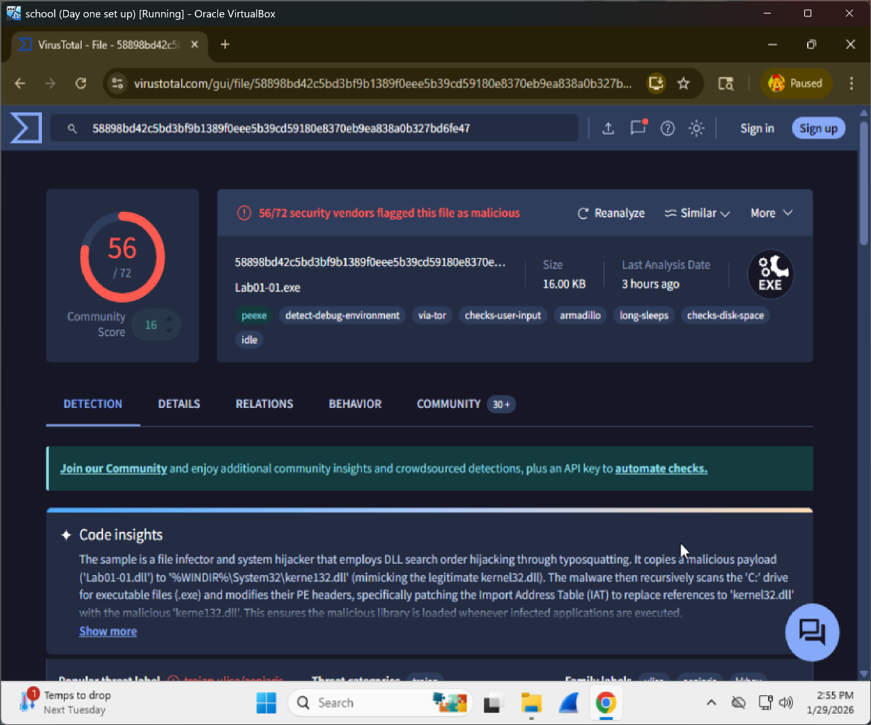

Lab01-01.dll:
Yes. This file was flagged as malicious by 40 out of 72 antivirus programs on VirusTotal, meaning it is also commonly detected as malware.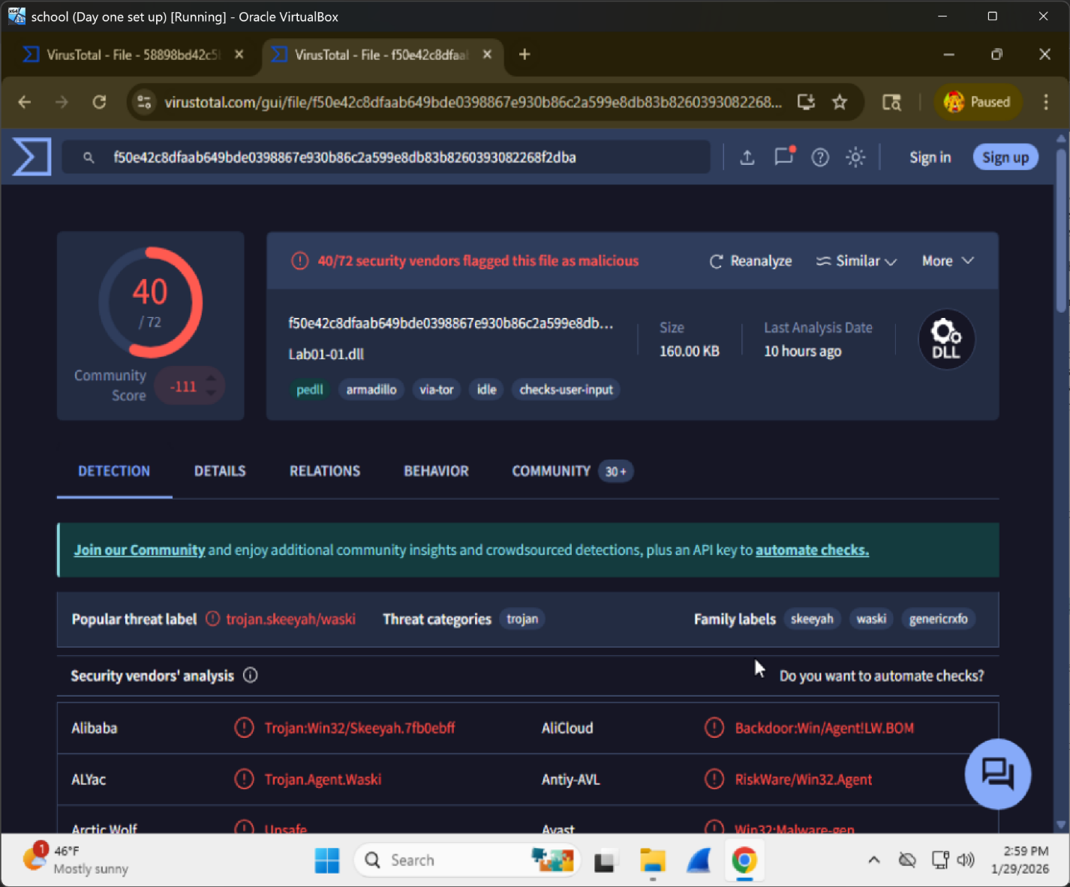

Question 2:
When were these files compiled?

Lab01-01.exe:
The file was compiled on December 19th, 2010 (UTC) seconds before the next file.
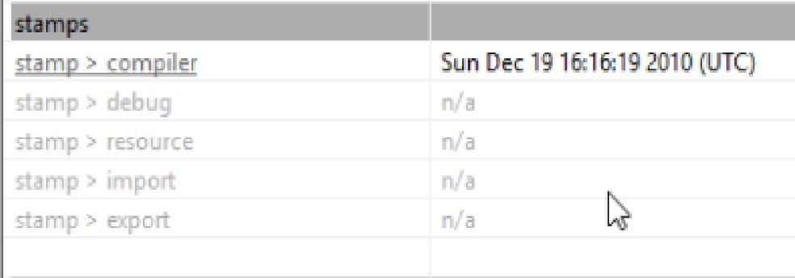
Lab01-01.dll:
The file was also compiled on December 19th, 2010 (UTC).
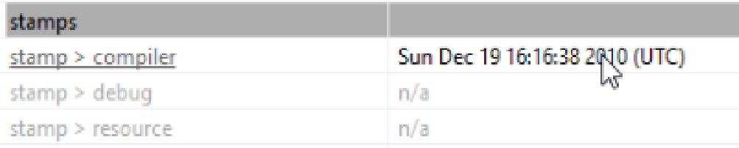

3. Are there any indications that either of these files is packed or obfuscated? If so, what are these indicators?

Lab01-01.exe:
There are no strong signs that Lab01-01.exe is packed or obfuscated. The file has a low entropy value (1.954), which means the data is not heavily scrambled or encrypted.
Lab01-01.dll:
There are no clear signs that Lab01-01.dll is packed or obfuscated. The file has a very low entropy value (0.129) .

4. Do any imports hint at what this malware does? If so, which imports are they?

Lab01-01.exe:
Yes some of the imports in Lab01-01.exe give clues about what the malware does. Imports like CreateFileA and CopyFileA show it can create and copy files. FindFirstFileA and FindNextFileA suggest it can search through folders. Other imports like MapViewOfFile show it can read files in memory. These imports suggest the program works with files on the system, which is suspicious behavior.
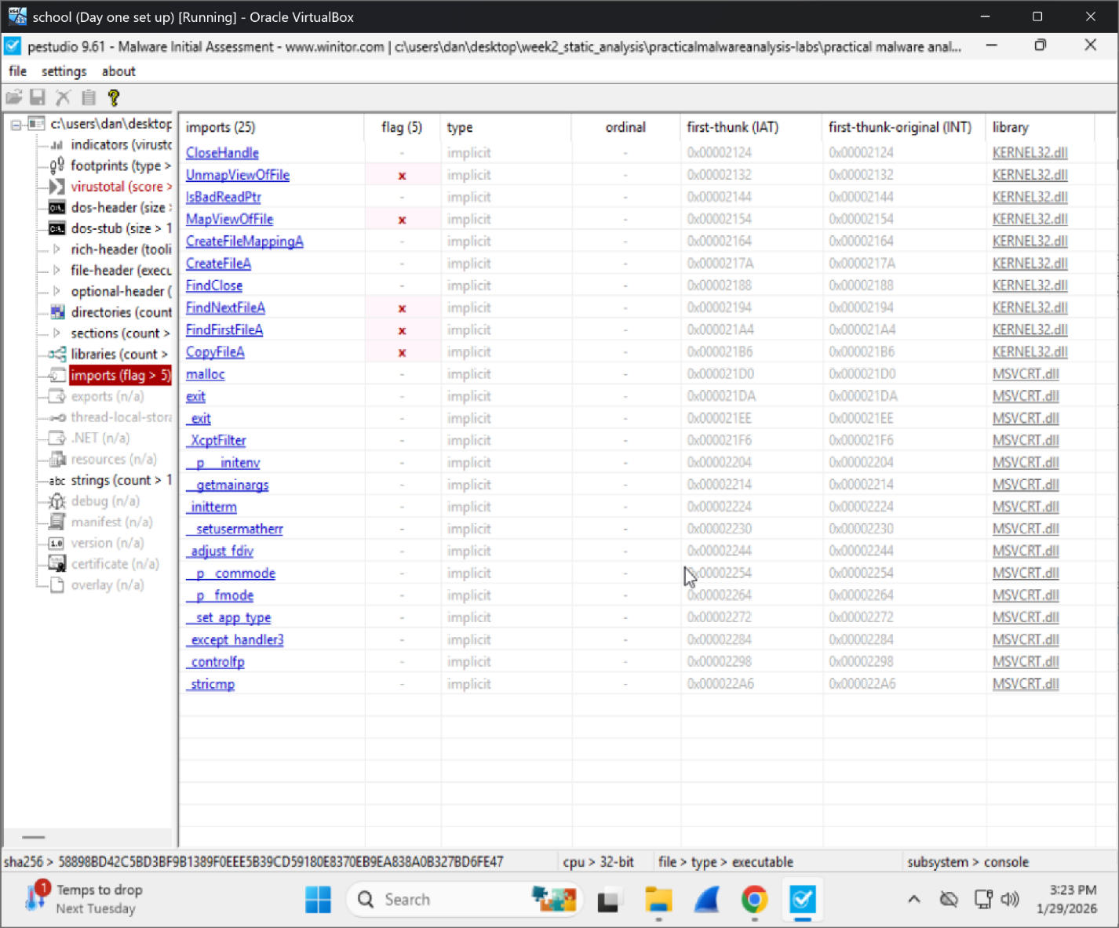

Lab01-01.dll:
Yes the imports in Lab01-01.dll give clues about what the malware does. Imports like socket, connect, send and recv show that the DLL can communicate over a network. The use of WSAStartup and WSACleanup also confirms that it uses Windows networking features. Other imports like CreateProcessA hint at it can start new processes. These imports kind of show what the DLL is used for network communication and remote control, which is risky behavior.
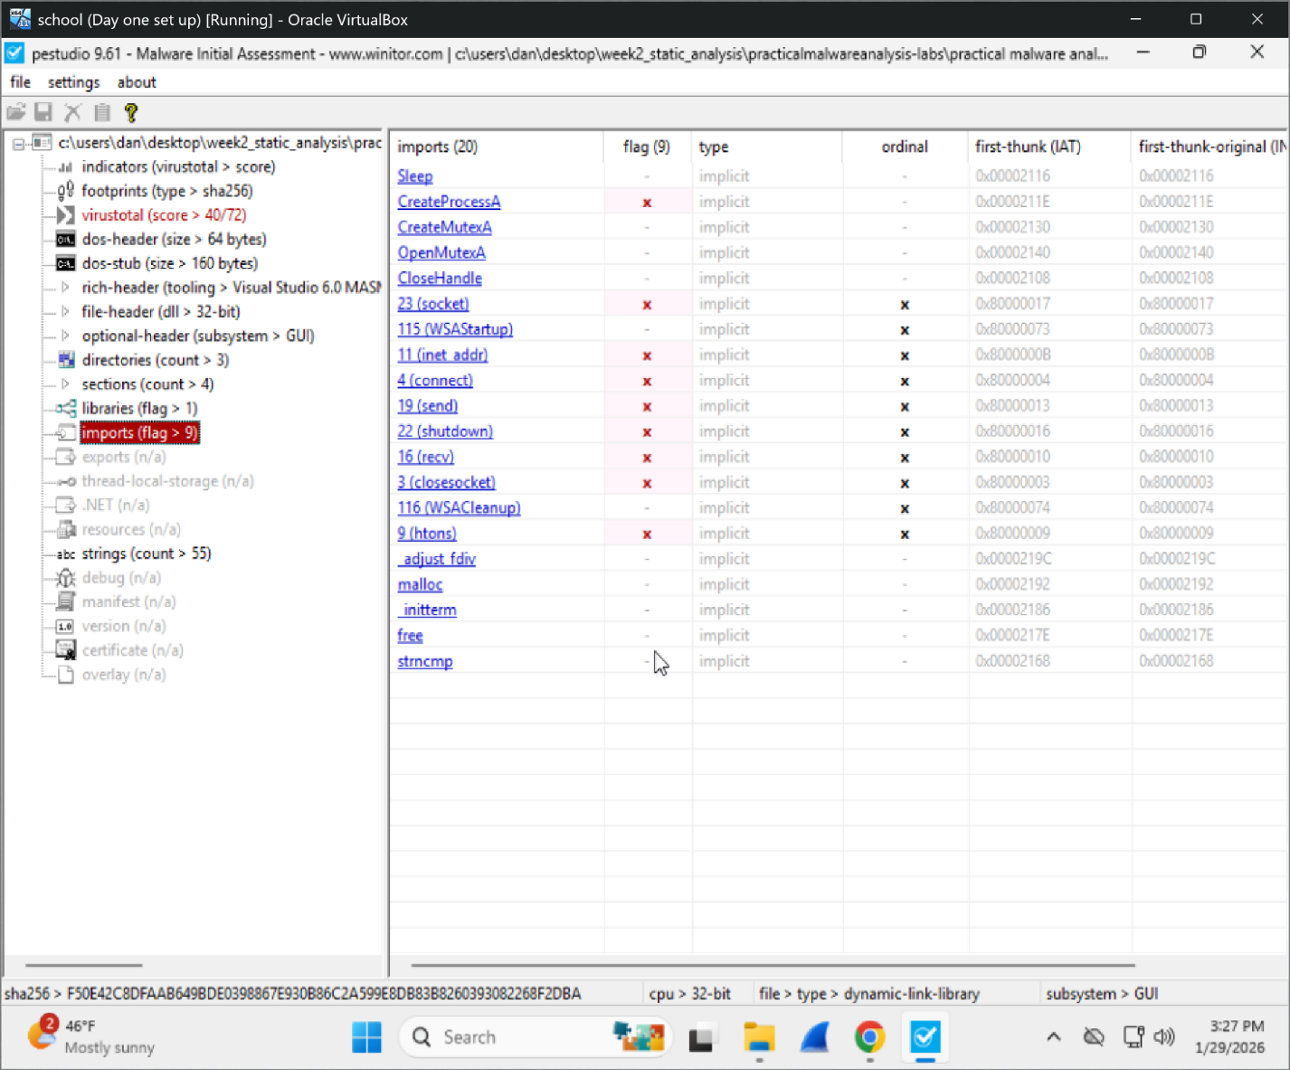

5. Are there any other files or host-based indicators that you could look for on infected systems?

Lab01-01.exe:
I checked both the imports and strings. The imports had functions like FindFirstFile, FindNextFile, CreateFile, and CopyFile which show the program can search through folders and copy files. The strings also show file paths like C:\ and references to .exe files. This suggests that on an infected system there may be unexpected copied files, modified executables, or changes in system directories.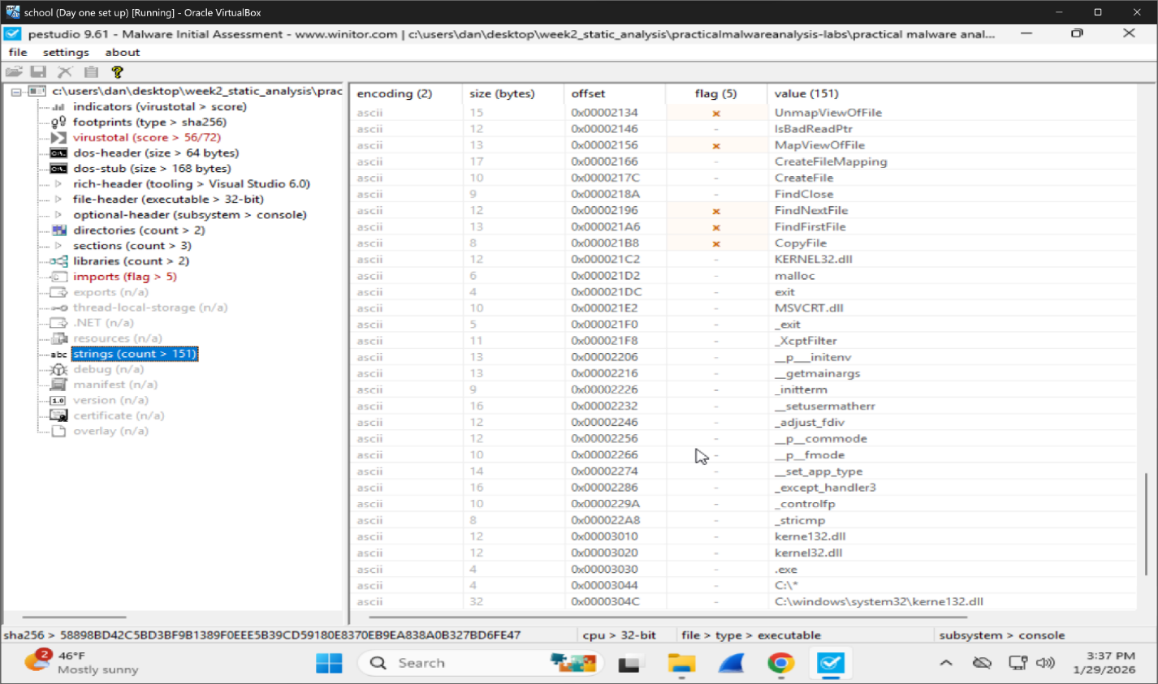

Lab01-01.dll:
To look for host based indicators related to Lab01-01.dll I checked the imports and strings. The imports show networking functions like socket, connect, send and recv, which suggests the DLL can communicate over a network. The strings also show items like 127.26.152.13, which could be a weird address to look for.
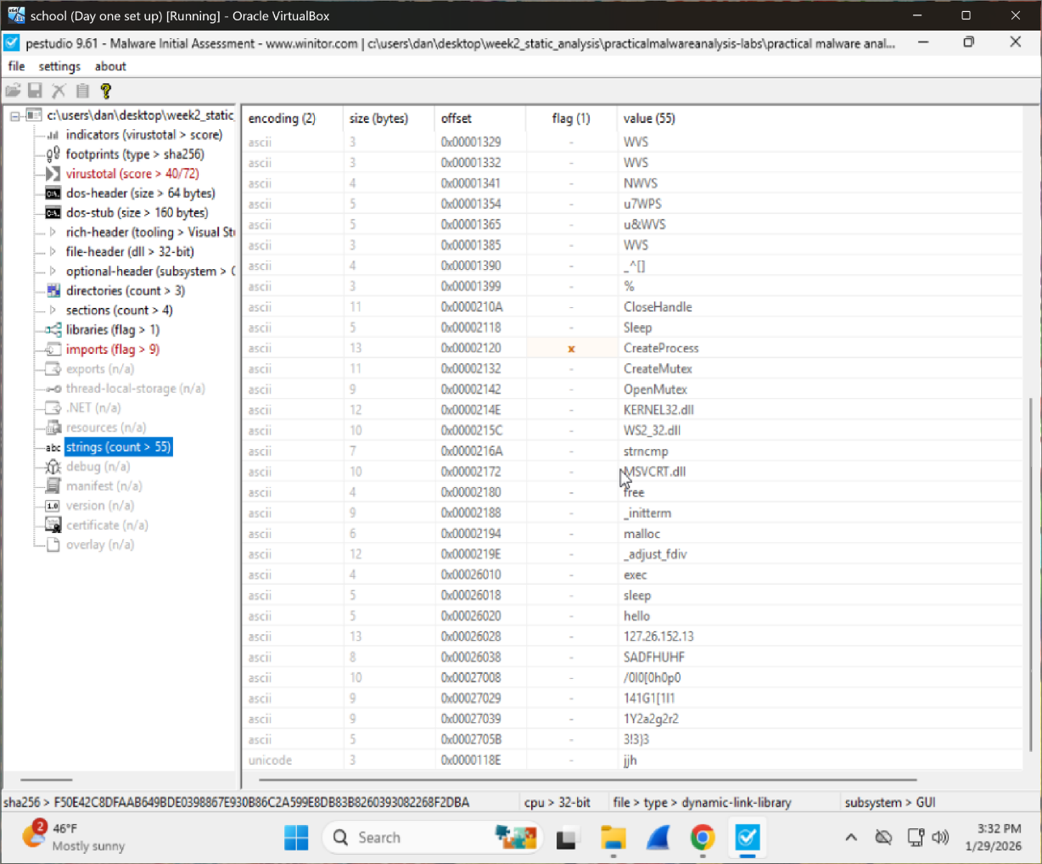

6. What network-based indicators could be used to find this malware on infected machines?
Lab01-01.exe:
Based on the imports there are no clear network-based indicators for this file. The executable does not import normal networking functions like socket, connect, send, recv. This suggests that Lab01-01.exe does not directly talk over the network and would not be detected through network traffic monitoring.
Lab01-01.dll:
The DLL uses networking functions like WSAStartup, socket, connect, send, and recv which shows it can make network connections and send or receive data. On an infected system this malware could be found by looking for unusual network traffic, unknown open connections, or communication with strange IP addresses or ports.

7. What would you guess is the purpose of these files?
Lab01-01.exe:
Based on the analysis Lab01-01.exe seems to search through the computer and copy or change files. It uses file related functions that suggest it looks for other executable files and spreads itself to them.
Lab01-01.dll:
Lab01-01.dll appears to handle network communication. It uses networking functions that let it connect to the internet and send or receive data. Both of them together the EXE and DLL likely work as a team, where the EXE spreads the malware and the DLL sends information back to the attacker.

Lab 1-3 Lab
Analyze the file Lab01-03.exe.
- Upload the Lab01-03.exe file to http://www.VirusTotal.com/. Does it match any existing antivirus definitions?
Yes. The file Lab01-03.exe matches existing antivirus definitions. It was flagged as malicious by 65 out of 71 antivirus engines which means its a strongly suggests that the file is malware.
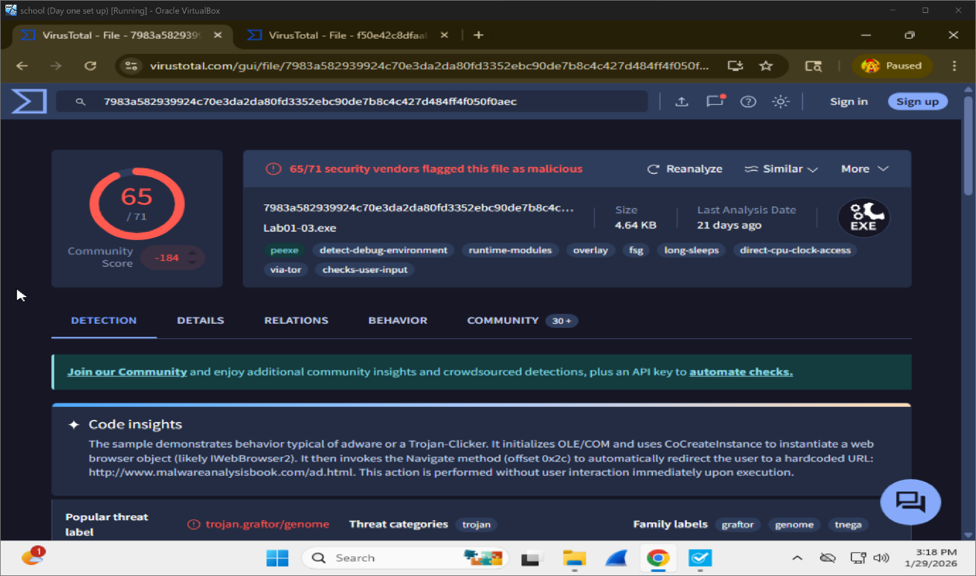

- Are there any indications that this file is packed or obfuscated? If so, what are these indicators? If the file is packed, unpack it if possible.
Yes there are signs that this file is packed or obfuscated. Indicators such as fsg and overlay. FSG is a packer and an overlay means extra data is attached to the file and is common in packed malware. The file is also very small which suggests the real code may be hidden.
- Do any imports hint at this program’s functionality? If so, which imports are they and what do they tell you?
The file Lab01-03.exe imports LoadLibraryA and GetProcAddress. These functions allow the program to load other libraries and functions while it is running instead of listing them ahead of time. This is often used by malware to hide its real behavior and make analysis harder.
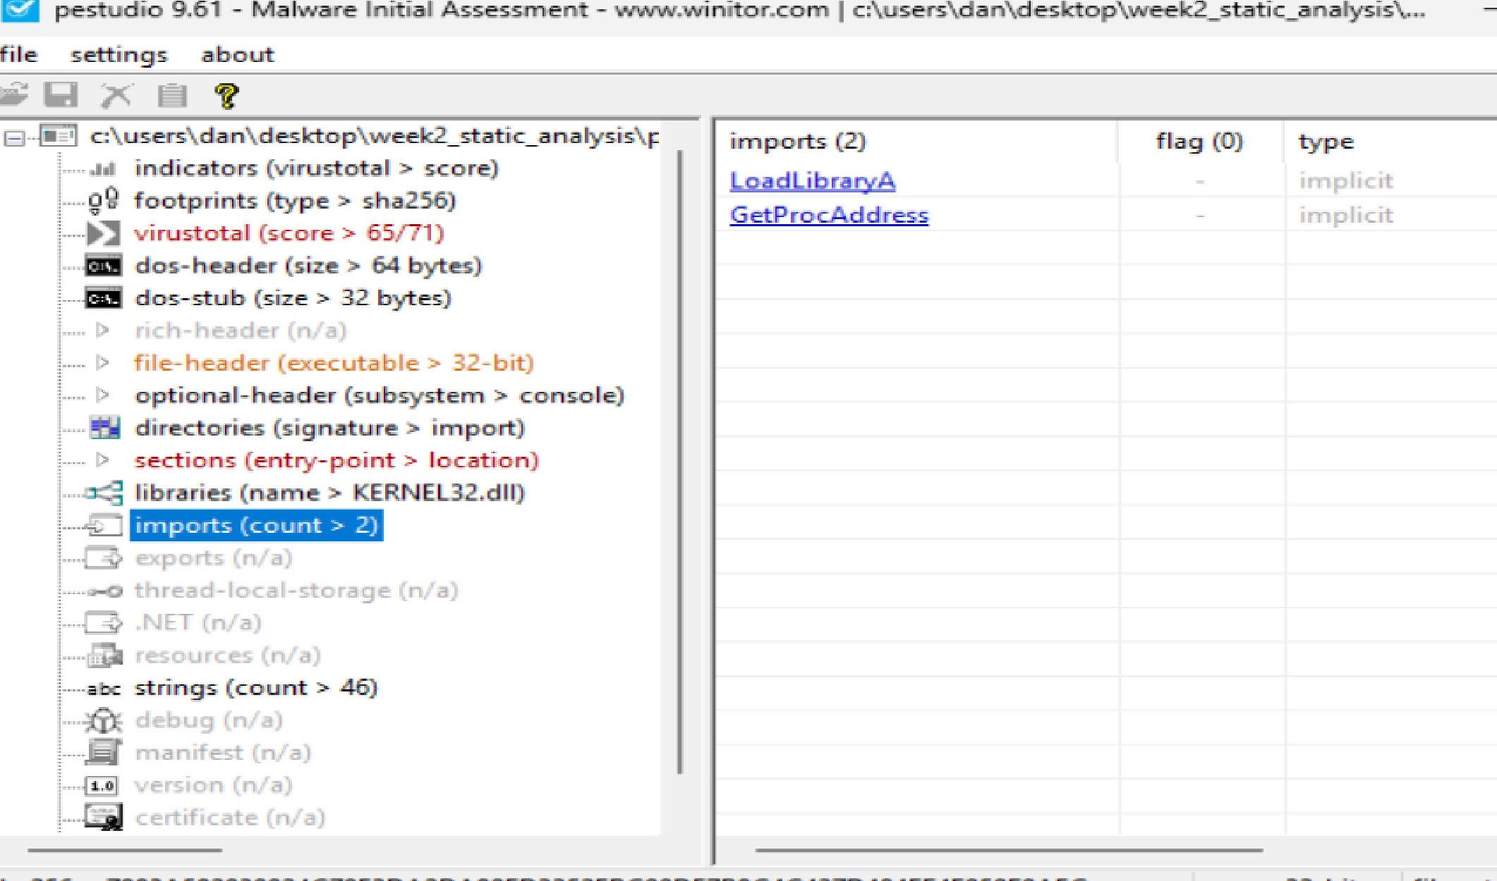

- What host- or network-based indicators could be used to identify this malware on infected machines?
Host-based indicators:
On an infected computer this malware could be found by looking for a strange or unknown EXE file like Lab01-03.exe running in Task Manager. The file only imports LoadLibraryA and GetProcAddress which can be a sign that it hides what it is doing. The strings also look random and that suggests the file is trying to hide stuff.
Network-based indicators:
This malware can open a web browser and connect to the internet without the user doing anything. If a computer starts opening web pages on its own or making internet connections that the user did not click on that is a strong sign this malware may be on the system. Unexpected outbound traffic or browser activity would be good network indicators to look for.

